COIT20265: Networks and Information Security Project

Assessment 2(B)

Submitted to:
Unit coordinator:
Biplob Roy

Mentor:
Ahmedi Azra

Submitted by:
Md Yeakub 12289551

Date of submission
11 May 2026

Contents
1. Evidence of Individual Contribution 4
1.1 Alignment with Project Proposal Task Allocation 4
1.2 Evidence: 4
6
2) Progress Demonstration 6
The website is divided into these major parts: 6
2. Part 1 — The <head> Section (Lines 1–7) 7
2.1 DOCTYPE and HTML Tag (Lines 1–2) 7
2.2 Meta Tags (Lines 4–5) 7
2.3 Page Title (Line 6) 7
2.4 Google Fonts (Line 7) 7
3. Part 2 — The CSS Styles (Lines 8–172) 7
3.1 CSS Variables / Colour Palette (Lines 9–23) 7
3.2 Global Reset & Base Styles (Lines 24–26) 8
3.3 Custom Scrollbar (Lines 27–29) 8
3.4 Navigation Bar Styles (Lines 31–49) 8
3.5 Hero Section Styles (Lines 51–66) 8
3.6 Log Ticker Styles (Lines 68–82) 9
3.7 Section & Card Styles (Lines 84–133 9
3.8 Monitor Section Styles (Lines 135–152) 9
3.9 Toast Notification Styles (Lines 159–164) 9
3.10 Responsive Styles (Lines 166–171) 9
4. Part 3 — The HTML Body (Lines 174–406) 10
4.1 Navigation Bar (Lines 176–193) 10
4.2 Hero Section (Lines 195–218) 10
4.3 Algorithm Section (Lines 220–290) 11
4.4 Why LogBERT Section (Lines 292–305) 12
4.5 Components & Services Section (Lines 307–323) 12
4.6 Demo Section (Lines 325–338) 13
4.7 Team Section (Lines 340–351) 14
4.8 Live Event Log Monitor (Lines 353–369) 14
4.9 Login Section (Lines 371–393) 15
4.10 Footer (Lines 395–404) 15
4.11 Toast Container (Line 406) 16
5. Part 4 — JavaScript (Lines 408–562) 16
5.1 Visitor IP Detection (Lines 411–414) 17
5.2 getTimestamp() — Lines 418 17
5.3 formatLogLine() — Lines 420–425 17
5.4 sendToCloudWatch() — Lines 428–439 17
5.5 logEvent() — Lines 442–448 (THE CORE FUNCTION) 18
5.6 addToMonitor() — Lines 451–464 18
5.8 showToast() — Lines 506–515 19
5.9 doLogin() — Lines 526–545 19
5.10 IntersectionObserver — Lines 548–554 19
5.11 escHtml() — Lines 556–558 19
5.12 Page Load & Unload Events — Lines 560–561 20
6. Where JavaScript Is Used in the HTML (Inline Events) 20
7. AWS Works 21
Stage 1: Static Website Hosted on Amazon S3 22
Stage 2: Website Event Logging 23
Stage 3: API Gateway and Lambda Log Receiver 24
Stage 4: Website Logs Stored in CloudWatc 26
8) Technical Accuracy and Depth 26
9) Critical Self-Assessment 27
9.1 Strengths 27
9.2 Areas for Improvement 28
10) Identification of Challenges and Problem-Solving Approaches 29
Challenge 1: Learning HTML, CSS, and JavaScript from Scratch 29
Challenge 2: AWS Services — API Gateway, Lambda, CloudWatch, and S3 29
Challenge 3: AWS Account Suspension 30
11) Evidence of learning and improvement 31
12) Plan for the rest of the project: 36

1. Evidence of Individual Contribution
My individual contribution to the LogGuard AI project centred on two tightly interconnected deliverables: (1) designing and building the complete LogGuard AI website from scratch using HTML, CSS, and JavaScript, and (2) engineering the cloud-based log pipeline that captures every user interaction on that website and forwards it in real time to AWS CloudWatch. These two components form the essential data-collection layer of the entire anomaly detection system, and both were conceived, implemented, and tested entirely by me.

1.1 Alignment with Project Proposal Task Allocation
In the Project Proposal my designated role was Data Analyst. The responsibilities assigned to this role included: setting up the AWS infrastructure, building the front-end website, implementing the event logging mechanism, and connecting the website activity to the anomaly detection pipeline via CloudWatch. Every deliverable I have produced in this assessment maps directly and verifiably to that role.
As we are at the end of the project so now I have done the real time website from where we are able to collect the real time log data from the user and it will store in the cloudwatch aws.
1.2 Evidence: I am providing my works evidence below:

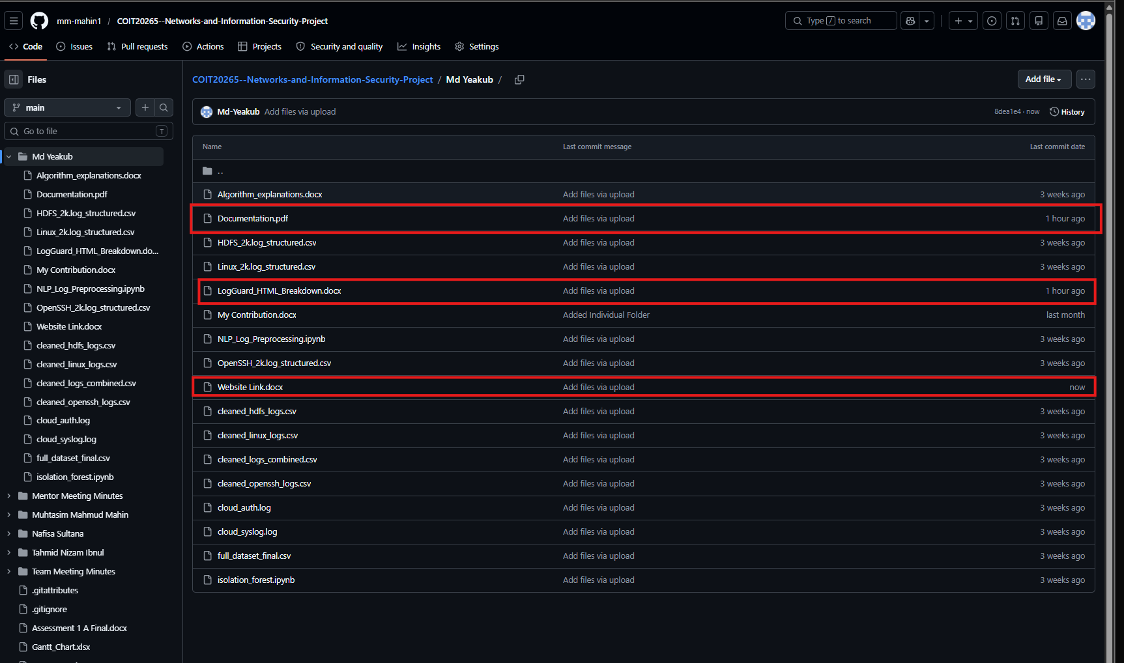
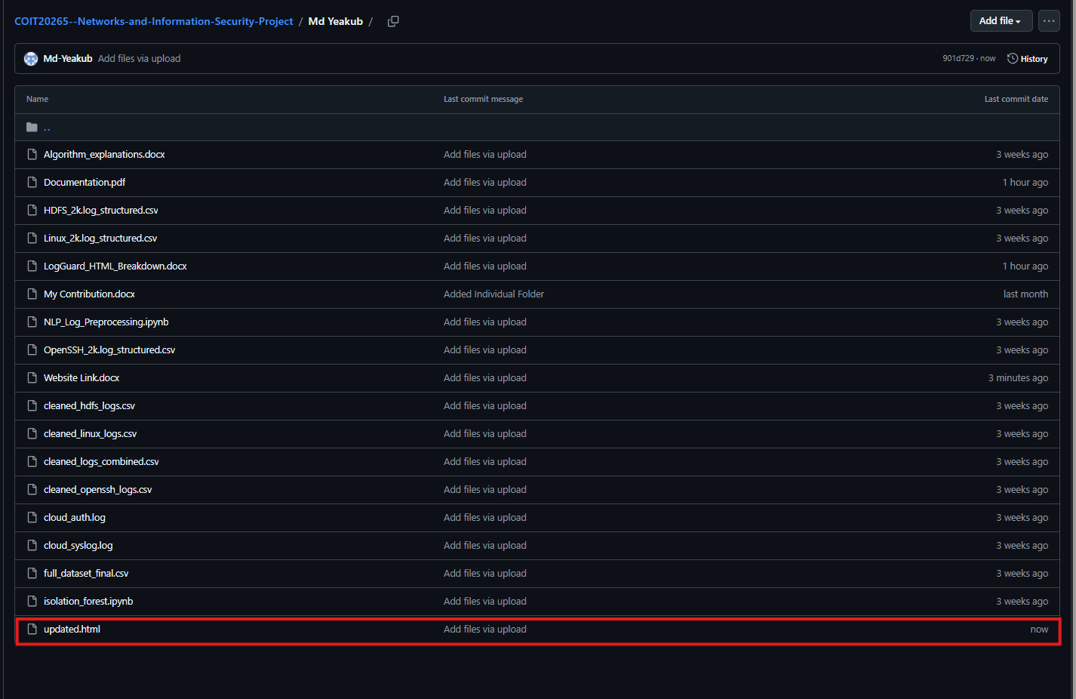

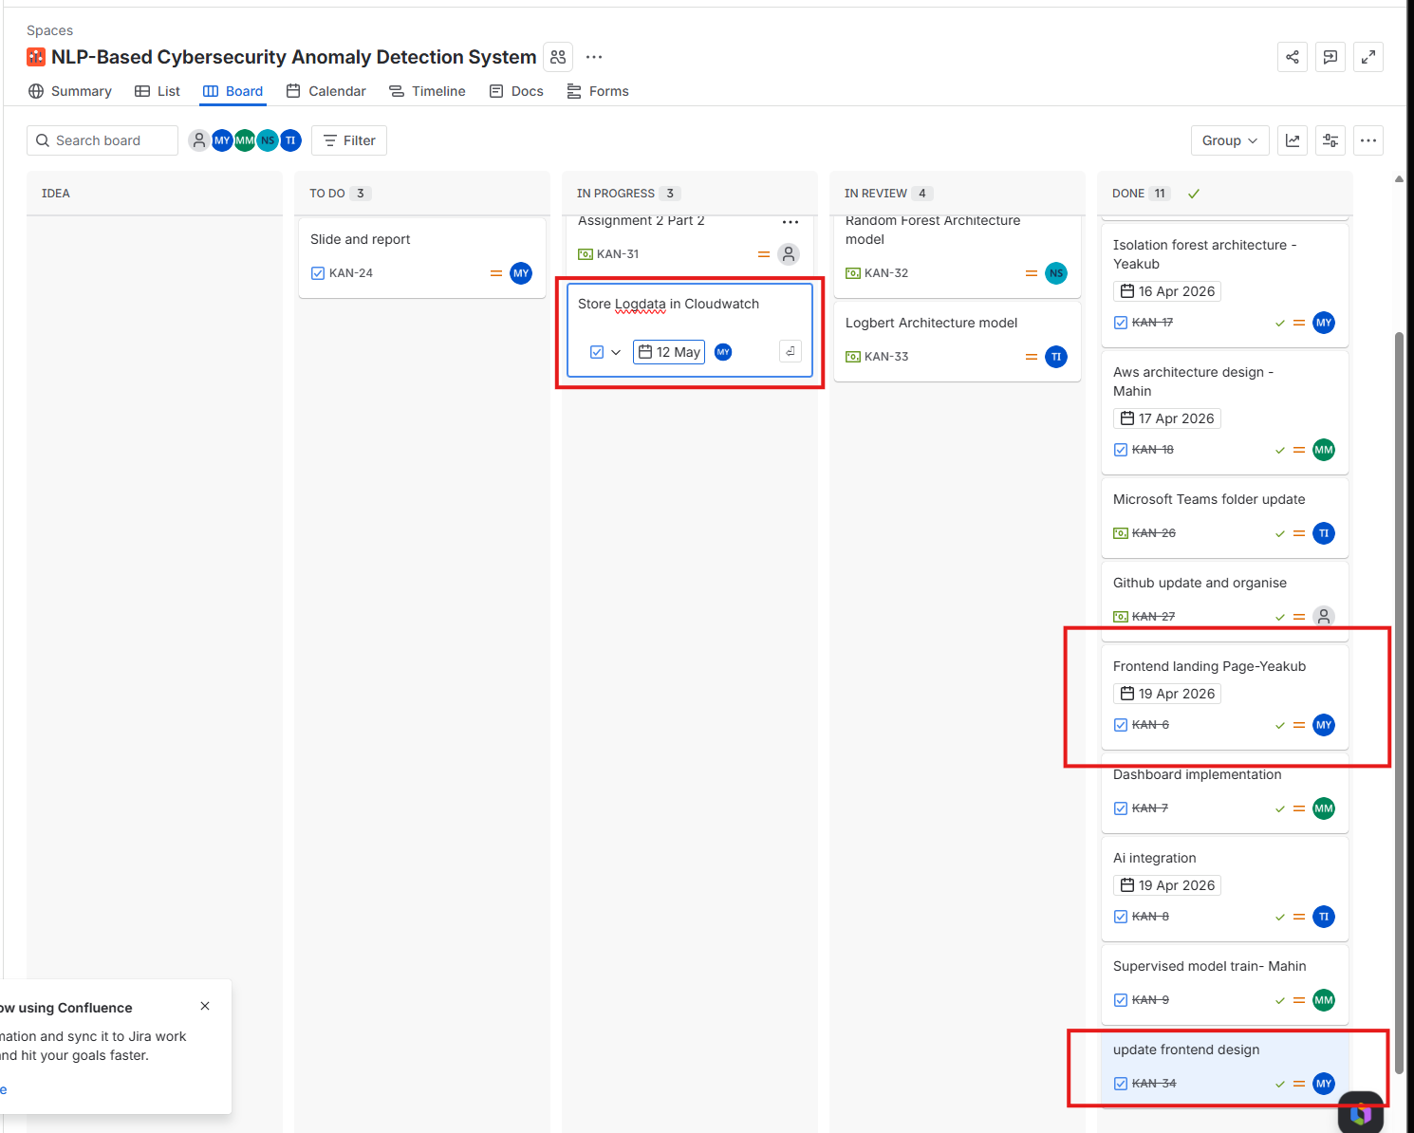
2) Progress Demonstration:
Document Overview
This document provides a complete part-by-part explanation of the index.html file for the LogGuard AI website — a CQUniversity COIT20265 project dashboard. The file is a single-page application (564 lines) containing HTML structure, embedded CSS styles, and inline JavaScript — all in one file.

The website is divided into these major parts:
- Lines 1–7: Document head — meta, title, Google Fonts
- Lines 8–172: Embedded CSS styles (all visual design)
- Lines 174–406: HTML body — 9 visible sections + footer + toast
- Lines 408–562: JavaScript block — all interactivity and logic

2. Part 1 — The <head> Section (Lines 1–7)
The <head> block sets up foundational document settings before anything is rendered on screen. It is invisible to the visitor but essential for how the browser interprets and displays the page.

2.1 DOCTYPE and HTML Tag (Lines 1–2)
<!DOCTYPE html>
<html lang="en">
Line 1 tells the browser this is a modern HTML5 document. Line 2 opens the HTML element and sets the language to English, which helps screen readers and search engines.

2.2 Meta Tags (Lines 4–5)
<meta charset="UTF-8">
<meta name="viewport" content="width=device-width, initial-scale=1.0">
charset="UTF-8" ensures all characters (including special symbols) display correctly. The viewport meta tag makes the website responsive — it tells mobile browsers not to zoom out and instead scale to the device width.

2.3 Page Title (Line 6)
<title>LogGuard AI — NLP-Based Log Anomaly Detection</title>
This text appears in the browser tab, bookmarks, and search engine results.

2.4 Google Fonts (Line 7)
<link href="https://fonts.googleapis.com/css2?family=Syne:wght@400;600;700;800&family=DM+Sans:wght@300;400;500&family=DM+Mono:wght@400;500&display=swap" rel="stylesheet">
Three typefaces are loaded from Google Fonts:
- Syne — Used for headings (h1, h2, logo). Bold and modern.
- DM Sans — The main body font for paragraphs and buttons.
- DM Mono — Monospace font used for log output and code-style text.

3. Part 2 — The CSS Styles (Lines 8–172)
All visual styling for the entire website is written inside a single <style> block in the <head>. There is no separate CSS file. Below is each CSS region explained.

3.1 CSS Variables / Colour Palette (Lines 9–23)
:root { --navy: #0a0f1e; --blue: #2563eb; --cyan: #06b6d4; --green: #10b981; ... }
The :root block defines global CSS custom properties (variables). Every colour used on the site is defined here once and referenced throughout. This means changing --blue in one place updates every button, link and highlight simultaneously.
- --navy / --navy2 / --navy3: Dark background colours (near-black blues)
- --blue / --blue2: Primary action colour for buttons and highlights
- --cyan: Used for hostname text in log outputs
- --green: Success states, normal log lines, status dots
- --red: Anomaly/error states in log lines
- --orange: Warning states and service names in logs
- --muted: Secondary grey text throughout
- --border: Subtle white border with low opacity
- --card: Glass-effect card background

3.2 Global Reset & Base Styles (Lines 24–26)
*, *::before, *::after { box-sizing: border-box; margin: 0; padding: 0; }
html { scroll-behavior: smooth; }
body { font-family: DM Sans; background: var(--navy); color: var(--white); overflow-x: hidden; }
The universal selector (*) resets all browser defaults so every element behaves consistently. scroll-behavior: smooth enables animated scrolling when nav links are clicked. The body sets the dark navy background and white text.

3.3 Custom Scrollbar (Lines 27–29)
::-webkit-scrollbar { width: 4px; }
::-webkit-scrollbar-thumb { background: var(--blue); border-radius: 2px; }
This gives Chrome/Edge/Safari a slim 4px blue scrollbar on the right side of the page instead of the default chunky grey one.

3.4 Navigation Bar Styles (Lines 31–49)
The nav CSS makes the top bar:
- Fixed to the top of the screen (position: fixed) — it stays visible while scrolling
- Uses backdrop-filter: blur(20px) for a frosted glass effect over content below
- The .logo-dot gets a pulse animation (keyframe defined at line 42)
- .nav-btn is the blue "View Demo" button — hover lifts it with translateY(-1px)
- .nav-btn-ghost is the transparent "Login" button with a subtle border

3.5 Hero Section Styles (Lines 51–66)
The hero takes up the full viewport height (min-height: 100vh) and centres its content. Two decorative elements are defined here:
- .hero-grid: A CSS grid pattern background made with repeating linear-gradients and masked with a radial gradient so it fades at the edges
- .hero-glow: A large blurred blue radial-gradient circle positioned behind the heading text
- @keyframes fadeUp: The animation that makes the badge, heading, subtitle and buttons fade in from below (used via animation-delay to stagger each element)

3.6 Log Ticker Styles (Lines 68–82)
These styles define the terminal-style log window visible at the bottom of the hero. It uses monospace font (DM Mono) and colour-codes each part of a log line:
- .log-ts — Timestamp in dark grey
- .log-host — Hostname in cyan
- .log-svc — Service name in orange
- .log-msg — Message text in light grey
- .log-msg.anomaly — Red for anomalous events
- .log-msg.warn — Orange for warnings
3.7 Section & Card Styles (Lines 84–133)
These classes control all the main content cards across the site:
- .why-card — The "Why LogBERT?" feature cards. Hover adds a blue border and lifts by 3px.
- .comp-card — The architecture component cards. Hover adds a cyan border.
- .team-card — Team member cards. Hover adds a blue border and lifts.
- .comp-badge — Small coloured pill labels (AWS, ML, UI, Alerts)
- .avatar — Circular initial icons for team members

3.8 Monitor Section Styles (Lines 135–152)
Styles the live log monitor which has a pure black (#000) background to look like a real terminal. Log lines are colour-coded identically to the hero ticker but with slightly different class names (.ml-msg.anom, .ml-msg.warn, .ml-msg.ok).

3.9 Toast Notification Styles (Lines 159–164)
The toast system shows small popup notifications in the bottom-right corner whenever a user interaction is logged. Each toast:
- Has a 3px left border coloured green (normal), red (anomaly), or orange (warning)
- Uses @keyframes toastIn to slide in from the right
- Is fixed-positioned and stacks vertically

3.10 Responsive Styles (Lines 166–171)
@media(max-width: 768px) { nav { padding: 1rem 1.5rem; } .nav-links { display: none; } ... }
At screen widths below 768px (phones and small tablets), the navigation links are hidden, section padding is reduced from 4rem to 1.5rem, and layout spacing is tightened. This is the only media query in the file.

4. Part 3 — The HTML Body (Lines 174–406)
The body contains nine visible sections plus a footer and a hidden toast container. Each section is explained below with its line numbers and a screenshot.

4.1 Navigation Bar (Lines 176–193)
The fixed navigation bar with logo, links, and action buttons
The <nav> element contains:
- Logo (Line 178): An <a> tag linking to #hero with a pulsing blue dot beside the text "LogGuard AI". Clicking it calls logEvent() to record the interaction.
- Nav Links (Lines 182–188): Five anchor links — Algorithm, Why LogBERT, Components, Team, Live Logs — each calling logEvent() on click for CloudWatch logging.
- Action Buttons (Lines 190–191): "View Demo" (blue button → jumps to #demo) and "Login" (ghost button → jumps to #login).

4.2 Hero Section (Lines 195–218)
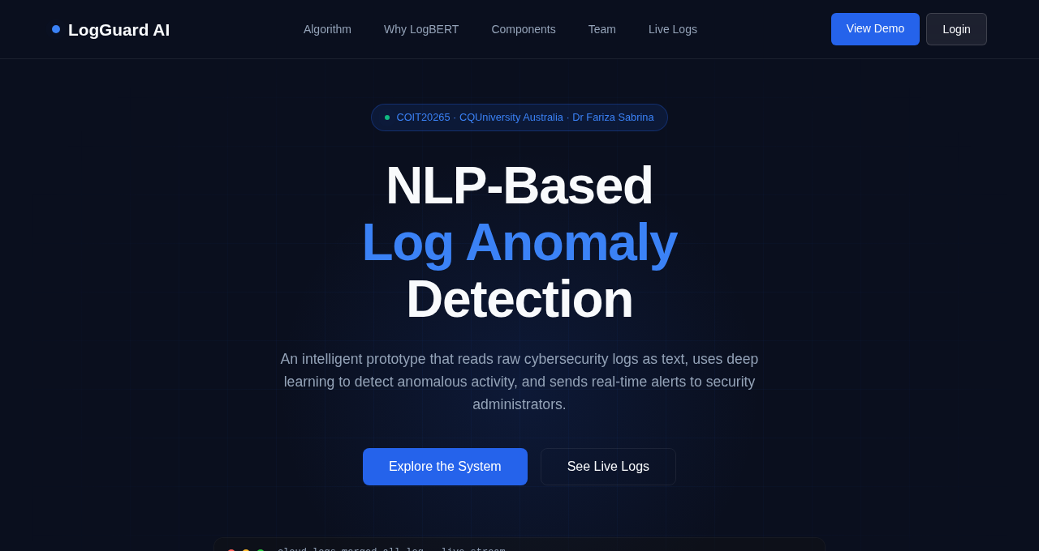
Hero section with heading, subtitle, CTA buttons, and live log ticker
The hero is the full-screen landing area at the top of the page. It contains:
- Background effects (Lines 197–198): .hero-grid (CSS grid overlay) and .hero-glow (blue radial glow) — purely decorative.
- Badge (Lines 200–203): A small pill showing "COIT20265 · CQUniversity Australia · Dr Fariza Sabrina" with a pulsing green dot.
- Heading (Line 204): "NLP-Based Log Anomaly Detection" in Syne font. The words "Log Anomaly" are wrapped in <span> to colour them blue.
- Subtitle (Line 205): A short description paragraph.
- Buttons (Lines 207–208): "Explore the System" scrolls to #algorithm; "See Live Logs" scrolls to #monitor. Both use JavaScript smooth scrolling.
- Log Ticker (Lines 210–216): A macOS-style terminal window (with red/amber/green dots) containing a div#log-feed that is populated by JavaScript with streaming log lines every 1.8 seconds.

4.3 Algorithm Section (Lines 220–290)
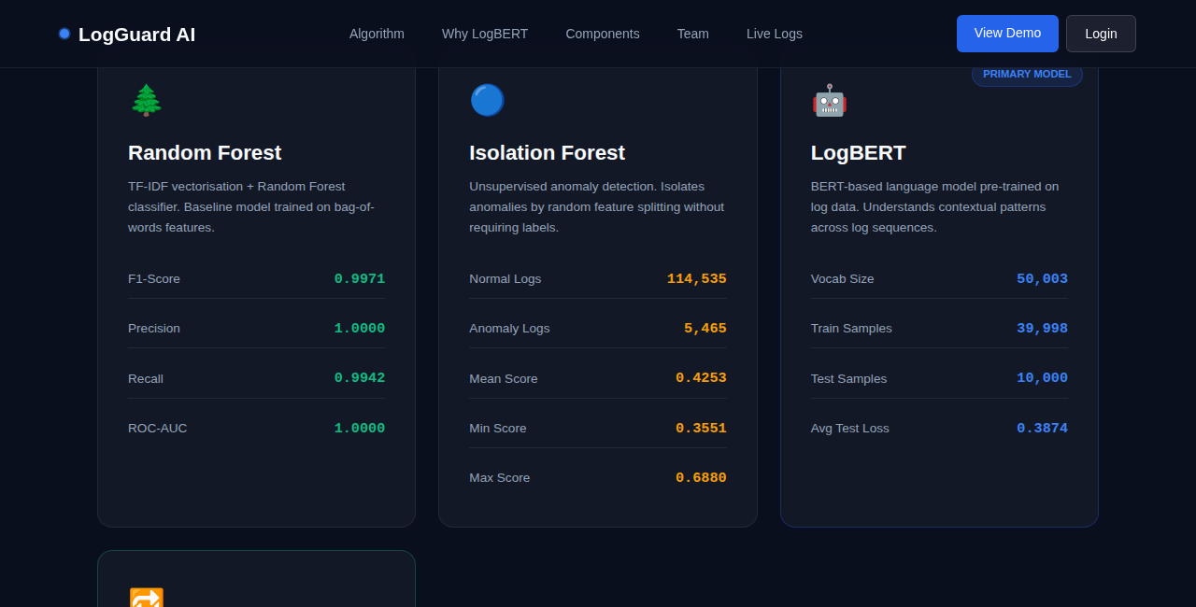
Algorithm cards showing model metrics for Random Forest, Isolation Forest, LogBERT, and LSTM
This section presents four algorithm comparison cards in a responsive CSS grid. Each card contains:
- An emoji icon and algorithm name heading
- A short description paragraph
- A table of performance metrics (F1-Score, Precision, Recall, ROC-AUC for supervised models; Normal/Anomaly counts for Isolation Forest)
- LogBERT card (Lines 259–272) has a "PRIMARY MODEL" badge in the top-right corner and a highlighted blue border
- All four cards have onmouseover/onmouseout handlers to change their border colour on hover, and onclick handlers to log the interaction

4.4 Why LogBERT Section (Lines 292–305)
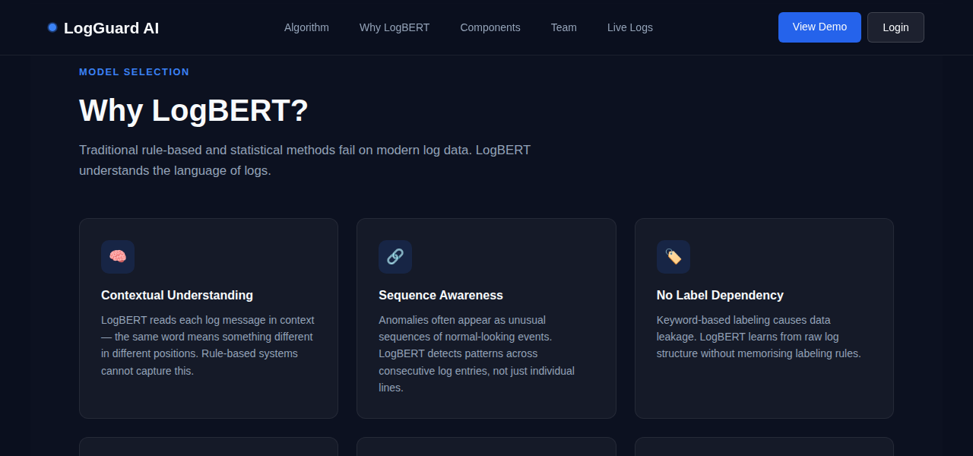
"Why LogBERT?" section with six feature cards
Six .why-card elements arranged in a responsive grid, each explaining a reason why LogBERT was chosen as the primary model:
- Contextual Understanding — LogBERT reads logs in context
- Sequence Awareness — Detects patterns across consecutive entries
- No Label Dependency — Avoids keyword-based data leakage
- Real-World Generalisation — Pre-trained on billions of tokens
- Production Speed — Processes 430 entries in under 2.4 seconds
- Explainable Outputs — Returns probability scores and matched keywords
Every card has an onclick that fires logEvent() to record which card was clicked.

4.5 Components & Services Section (Lines 307–323)
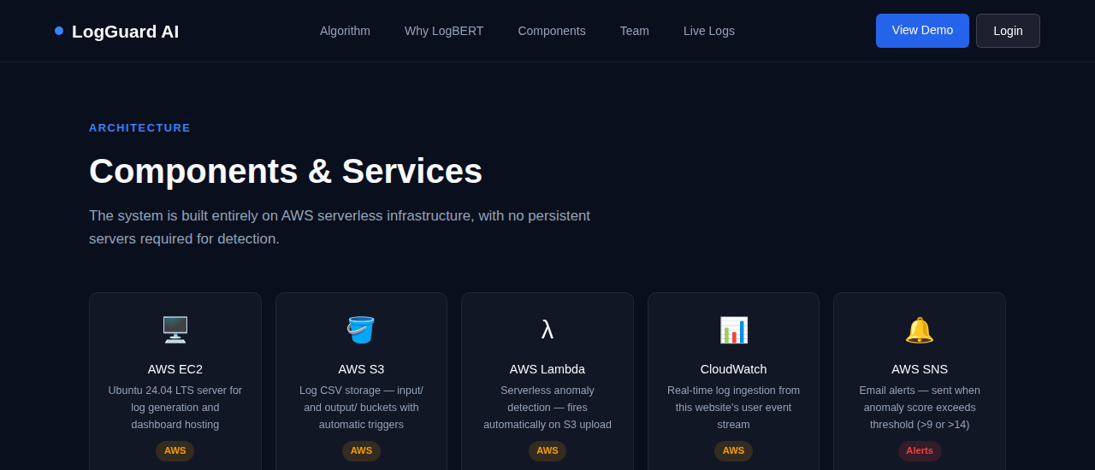
Architecture components grid showing AWS services and ML models
Nine .comp-card elements in a tight grid, each representing one part of the system architecture:
- AWS EC2 — Ubuntu server for log generation and dashboard hosting
- AWS S3 — Input/output CSV buckets with event triggers
- AWS Lambda — Serverless inference engine, auto-fires on S3 upload
- CloudWatch — Ingests user events from this website in real time
- AWS SNS — Sends email alerts when anomaly score exceeds threshold
- LogBERT — Primary BERT model (avg test loss: 0.3874)
- TF-IDF + Random Forest — Baseline model (F1=0.9971)
- Streamlit Dashboard — Visual interface for scores and alerts
- Python Algorithm — anomaly_algorithm.py connecting ML to AWS
Each card has a coloured badge: AWS (amber), ML (blue), UI (green), Alerts (red).

4.6 Demo Section (Lines 325–338)
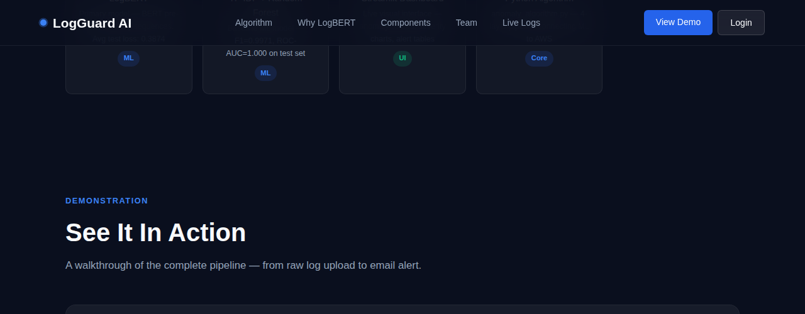
Demo section with play button and link to live Streamlit dashboard
A demo-box with a macOS-style window chrome (three coloured dots). Inside:
- A circular blue play button (▶) — clicking logs the event but no video is attached yet ("Coming soon" message)
- "Open Live Dashboard →" button that opens http://100.31.56.196:8501 in a new tab — this links to the real Streamlit dashboard running on the EC2 instance

4.7 Team Section (Lines 340–351)
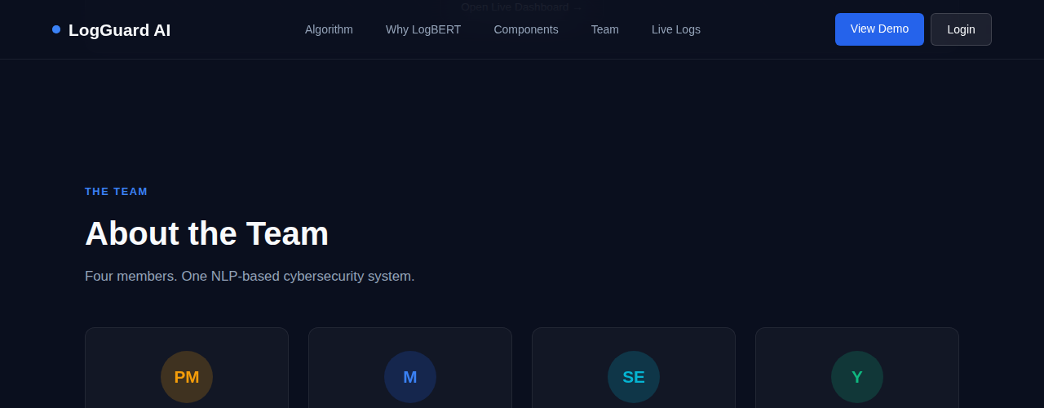
Team section showing four project members with their roles
Four .team-card elements, one per team member:
- Tahmid (PM) — Project Manager: scheduling, reports, stakeholder communication, demo
- Mahin (M) — Cloud Engineer: AWS setup, Python algorithm, log generation, this website
- Nafisa Sultana (SE) — Software Engineer: system integration, architecture, API design
- Yeakub (Y) — Data Analyst / NLP Developer: data preprocessing, model training, evaluation
Each card has a circular avatar with initials, coloured with a different theme (orange, blue, cyan, green).

4.8 Live Event Log Monitor (Lines 353–369)
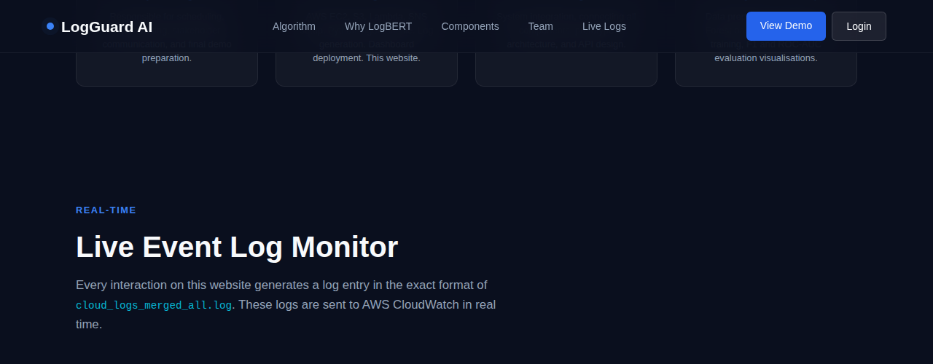
Live event log monitor that records every user interaction on the page
This is a real-time terminal that shows every interaction the user makes on the website formatted as a server log line. The monitor contains:
- A header bar with the stream name, a pulsing green LIVE indicator, and a "clear" button
- A scrollable div#monitor-feed that shows interaction logs as they happen
The explanatory note below the monitor reads: "Click any button or card on this page to generate a log entry above." This demonstrates the logging pipeline — user clicks → JavaScript → CloudWatch.

4.9 Login Section (Lines 371–393)
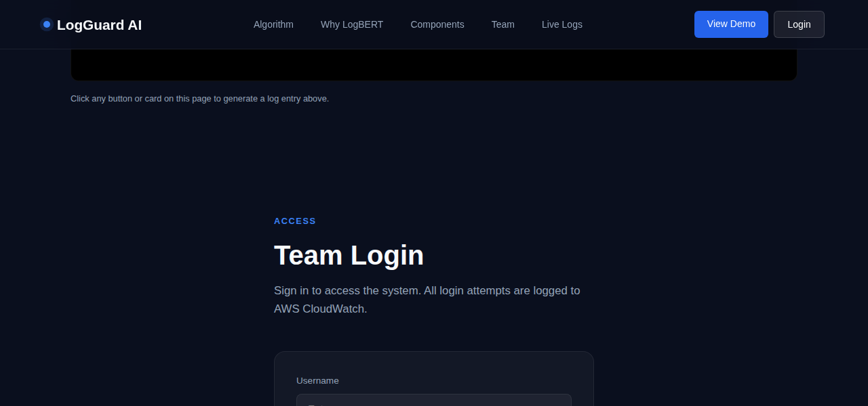
Team Login section with username and password fields
A simple login form for team members. It contains:
- Username input (Line 379–381): Text field with focus/blur border-colour change via onfocus and onblur handlers
- Password input (Lines 385–388): Password field. Pressing Enter triggers doLogin() via onkeydown
- Sign In button (Line 390): Calls doLogin() on click. Hover changes background colour via onmouseover/onmouseout
- Message div (Line 391): Hidden by default. Shows green success or red error messages after login attempt

4.10 Footer (Lines 395–404)
Footer with project credits and navigation links
A simple footer with two parts:
- Left: "LogGuard AI — COIT20265 · CQUniversity Australia · Dr Fariza Sabrina"
- Right: Four anchor links (Home, Algorithm, Team, Live Logs) — each fires logEvent() on click

4.11 Toast Container (Line 406)
<div id="toast-container"></div>
An empty div fixed to the bottom-right of the screen. JavaScript dynamically inserts toast notification elements here whenever logEvent() is called. The container is invisible until toasts appear.

5. Part 4 — JavaScript (Lines 408–562)
All JavaScript is written inside a single <script> block at the bottom of the <body>. Placing scripts at the bottom is best practice — it ensures the HTML has fully loaded before the JS runs. The JavaScript powers six major features:
Summary of All JavaScript Features
Lines | JS Feature / Function | What It Does
411–414 | Visitor IP Fetch | Fetches the real visitor IP from api.ipify.org to embed in log lines as the hostname
416 | PID Counter | Simulates a Unix process ID counter (starts at 1000, increments with each log event)
418 | getTimestamp() | Returns the current ISO timestamp in UTC format for log lines
420–425 | formatLogLine() | Builds a Unix syslog-format log string: timestamp + IP + service[PID]: message
428–439 | sendToCloudWatch() | POSTs log lines to a Flask /log endpoint which forwards them to AWS CloudWatch
442–448 | logEvent() | Master event logger — called by every button and card. Pipes to monitor, ticker, toast, and CloudWatch simultaneously
451–464 | addToMonitor() | Parses a log line and appends a colour-coded row to the live monitor feed div
467–503 | Hero Ticker | Streams simulated SSH/CRON/sudo log entries into the hero terminal at 1.8-second intervals
506–515 | showToast() | Creates a toast popup notification in the bottom-right corner, auto-removes after 2.8 seconds
518–545 | doLogin() | Validates username/password against a hardcoded list. Logs success or failure to CloudWatch
548–554 | IntersectionObserver | Scroll animation — cards fade in from below as they enter the viewport
556–558 | escHtml() | Security helper — sanitises strings before inserting into innerHTML to prevent XSS
560–561 | Page Load/Unload | Logs when a user arrives on or leaves the website

5.1 Visitor IP Detection (Lines 411–414)
fetch('https://api.ipify.org?format=json')
.then(r => r.json())
.then(data => { HOSTNAME = data.ip; })
Purpose: Makes an HTTP GET request to the free public API api.ipify.org which returns the visitor's real public IP address. This IP is then used as the "hostname" field in all generated log lines, making them look exactly like real server logs (e.g. 2025-05-06T10:23:11+00:00 203.12.45.67 website-nav[1001]: User clicked logo).
If the request fails (network error or blocked), HOSTNAME falls back to the string "ip-unknown".

5.2 getTimestamp() — Lines 418
function getTimestamp() { return new Date().toISOString().replace("Z", "+00:00"); }
Purpose: Returns the current date and time in ISO 8601 format with timezone offset instead of the default "Z" suffix. Example output: 2025-05-06T10:23:11.452+00:00. This matches the timestamp format of real Linux syslog entries.

5.3 formatLogLine() — Lines 420–425
function formatLogLine(category, action, message) {
const ts = getTimestamp();
const pid = PID_COUNTER++;
const service = "website-" + category + "[" + pid + "]:";
return ts + " " + HOSTNAME + " " + service + " " + message;
}
Purpose: Assembles the full log line in Unix syslog format. For example, if category="nav" and message="User clicked logo", it produces:
2025-05-06T10:23:11+00:00 203.12.45.67 website-nav[1001]: User clicked logo
This format is identical to real cloud_logs_merged_all.log entries, so these website events can be fed directly into the LogBERT anomaly detection pipeline.

5.4 sendToCloudWatch() — Lines 428–439
async function sendToCloudWatch(logLine) {
await fetch('/log', {
method: 'POST',
headers: { 'Content-Type': 'application/json' },
body: JSON.stringify({ message: logLine })
});
}
Purpose: Sends the formatted log line to a Flask web server running on the EC2 instance at the /log endpoint. The Flask server then forwards the message to AWS CloudWatch Logs. This is how every button click on this website creates a real CloudWatch log entry.
The function is async and uses a try/catch — if the Flask server is unreachable (e.g. running locally), the error is silently logged to the browser console and the website continues to function normally.

5.5 logEvent() — Lines 442–448 (THE CORE FUNCTION)
function logEvent(category, action, message) {
const logLine = formatLogLine(category, action, message);
addToMonitor(logLine, ...);
addToTicker(logLine, ...);
showToast(logLine, ...);
sendToCloudWatch(logLine);
}
Purpose: This is the central function called by every interactive element on the page. When any button, card, or link is clicked, logEvent() is called with three arguments:
- category — which section (e.g. "nav", "hero", "team", "login")
- action — what was clicked (e.g. "logo-click", "play-btn", "login-failed")
- message — a human-readable description (e.g. "User clicked LogGuard logo")
The function determines log severity by checking if the message contains "fail" or "wrong" (which marks it as an anomaly in red). It then sends the log to all four outputs simultaneously: the live monitor panel, the hero ticker, the toast popup, and AWS CloudWatch.

5.6 addToMonitor() — Lines 451–464
Purpose: Parses the raw log line string by splitting on spaces, then dynamically creates a new <div class="monitor-line"> element with four colour-coded <span> elements for timestamp (dark grey), hostname (cyan), service (orange), and message (grey/red/green). The "— waiting for events —" placeholder is replaced on the first real event. The feed is capped at 50 lines to prevent memory growth.
5.7 Hero Ticker & Background Streaming — Lines 467–503
Two separate mechanisms feed the hero log ticker:
- Background simulation (Lines 467–503): Eight pre-written SSH/CRON/sudo log templates (HERO_TEMPLATES array) are cycled through every 1,800ms using setInterval(streamBackground, 1800). This makes the ticker appear to be streaming real server logs even when no user interaction occurs. Templates include both normal logs (green) and anomaly logs (red) to demonstrate the detection system.
- Real event forwarding (Line 493): addToTicker() is called by logEvent() so user-triggered events also appear in the hero ticker in real time.

5.8 showToast() — Lines 506–515
Purpose: Creates a temporary popup notification for every logged event. The toast:
- Appears in the bottom-right corner (positioned by CSS)
- Shows the first 80 characters of the log line
- Has a green left border for normal events, red for anomalies
- Automatically fades out after 2.5 seconds and is removed from the DOM at 2.8 seconds
- Maximum 4 toasts are shown at once — older ones are removed if the limit is exceeded

5.9 doLogin() — Lines 526–545
Purpose: Handles the team login form. It reads values from the username and password input fields, validates them against a hardcoded list of 6 team accounts, and shows a styled message:
- Valid credentials → green success message → logEvent("login", "login-success", ...)
- Wrong credentials → red error message → logEvent("login", "login-failed", ...) — this generates an anomaly-level log in red
- Empty fields → red warning without logging
After each attempt the password field is cleared. The login-failed events are intentionally marked as anomalies (colour red in the monitor) to demonstrate how the system flags suspicious behaviour.
Note: The credentials are stored in plain text in the JavaScript source (lines 518–525). This is a prototype/demonstration only and would not be used in production.

5.10 IntersectionObserver — Lines 548–554
const observer = new IntersectionObserver((entries) => {
entries.forEach(e => { if (e.isIntersecting) {
e.target.style.opacity = "1";
e.target.style.transform = "translateY(0)";
}});
}, { threshold: 0.1 });
Purpose: Creates a scroll-triggered animation. All .why-card, .comp-card, .team-card, and .monitor-line elements start invisible (opacity:0) and shifted down (translateY 20px). As the user scrolls and each card enters the viewport (10% threshold), the observer fires and transitions the card to visible and in position over 0.5 seconds. This creates the "fade up on scroll" effect.

5.11 escHtml() — Lines 556–558
function escHtml(str) {
return String(str).replace(/&/g,"&amp;").replace(/</g,"&lt;").replace(/>/g,"&gt;").replace(/"/g,"&quot;");
}
Purpose: A security helper function that escapes HTML special characters before any string is inserted into innerHTML. This prevents Cross-Site Scripting (XSS) attacks — if a log message somehow contained HTML tags like <script>, they would be safely displayed as text instead of executed as code.

5.12 Page Load & Unload Events — Lines 560–561
window.addEventListener('load', () => { logEvent('system','page-load','User loaded LogGuard AI website — session started'); });
window.addEventListener('beforeunload', () => { logEvent('system','page-unload','User left LogGuard AI website — session ended'); });
Purpose: These two event listeners automatically log when a user arrives on the page (load) and when they leave (beforeunload — triggered by closing the tab, navigating away, or refreshing). This gives session start/end boundaries in CloudWatch, useful for understanding user session duration.

6. Where JavaScript Is Used in the HTML (Inline Events)
In addition to the <script> block, JavaScript is called inline throughout the HTML via onclick, onmouseover, onmouseout, onfocus, onblur, and onkeydown attributes. Here is where each appears:
Line | Element | Event | What It Does
178 | Logo link | onclick | Logs logo click to CloudWatch
183–187 | Nav links (×5) | onclick | Logs which section link was clicked
190 | "View Demo" button | onclick | Logs demo button click
191 | "Login" button | onclick | Logs login button click
207 | "Explore System" button | onclick | Logs + scrolls to #algorithm smoothly
208 | "See Live Logs" button | onclick | Logs + scrolls to #monitor smoothly
228–230 | Random Forest card | onclick + onmouseover/out | Logs click; border colour changes on hover
243–245 | Isolation Forest card | onclick + onmouseover/out | Same hover/log pattern
259–261 | LogBERT card | onclick + onmouseover/out | Same hover/log pattern
275–277 | LSTM card | onclick + onmouseover/out | Same hover/log pattern
298–303 | Why-cards (×6) | onclick | Logs which feature card was clicked
313–321 | Comp-cards (×9) | onclick | Logs which component card was clicked
333 | Play button | onclick | Logs demo play button click
335 | "Open Dashboard" btn | onclick | Logs click + opens Streamlit in new tab
346–349 | Team cards (×4) | onclick | Logs which team member card was clicked
363 | "clear" button | onclick | Clears monitor feed innerHTML
381 | Username input | onfocus / onblur | Blue border on focus, grey on blur
387–388 | Password input | onfocus / onblur / onkeydown | Border change + Enter key triggers doLogin()
390 | "Sign In" button | onclick + onmouseover/out | Calls doLogin(); hover changes background
399–402 | Footer links (×4) | onclick | Logs which footer link was clicked

7. AWS Works
LogGuard AI is a cloud-based log anomaly detection system that uses a LogBERT-based model to identify suspicious activity from log data. The system connects multiple AWS services to create a complete pipeline where logs are collected, analysed, stored, visualised, and used to generate automated security alerts.
The project demonstrates how raw log activity can be transformed into useful cybersecurity insights. The system does not only detect anomalies; it also stores the results, sends security email alerts with AI-generated response guidance, and displays the results through a dashboard.
The main stages are
- Website hosted on Amazon S3
- Website event logs generated from user activity
- Website logs sent through API Gateway and Lambda
- Website logs stored in CloudWatch

Stage 1: Static Website Hosted on Amazon S3
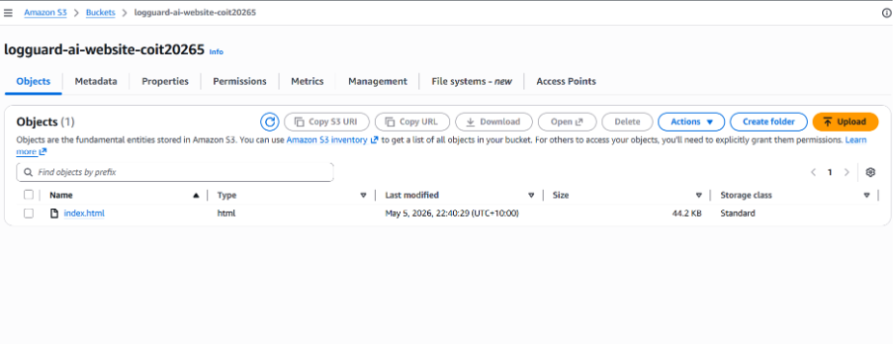
Figure 1: S3 bucket showing the uploaded website file
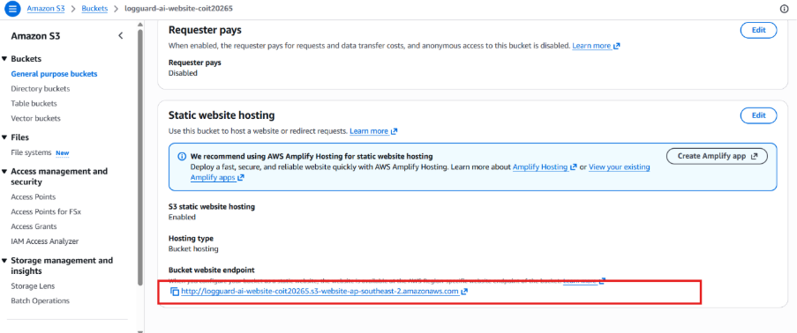
Figure 2: S3 static website hosting endpoint
The first stage of the project is the LogGuard AI website. The website is hosted using Amazon S3 static website hosting. This allows the website to run without a traditional web server, making it lightweight, simple to deploy, and suitable for a cloud-based demonstration.
The website acts as the front-facing part of the project. It introduces the LogGuard AI system, explains the model comparison, shows the project architecture, displays team information, and includes a live log monitor section.
The website is also connected to the logging pipeline. This means it does not only display project information; it also generates logs when users interact with it. The uploaded website file contains both the front-end interface and the JavaScript event logging logic used to send website activity into AWS.
This stage is important because it provides a realistic live source of user activity logs. Instead of relying only on static test files, the system can create new logs based on real website actions.

Stage 2: Website Event Logging
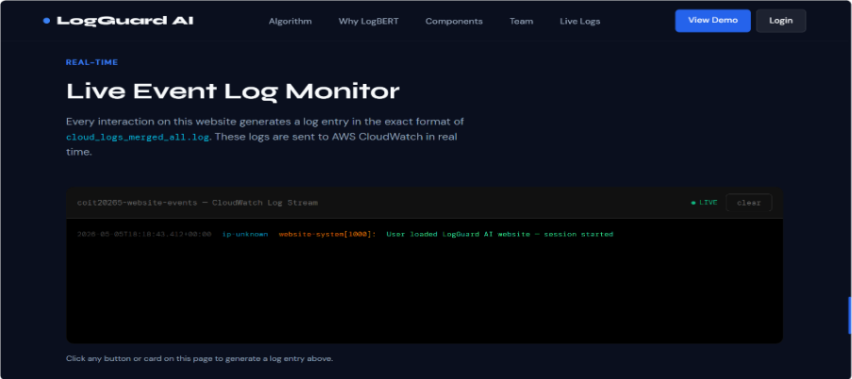
Figure 3: Website live log monitor section
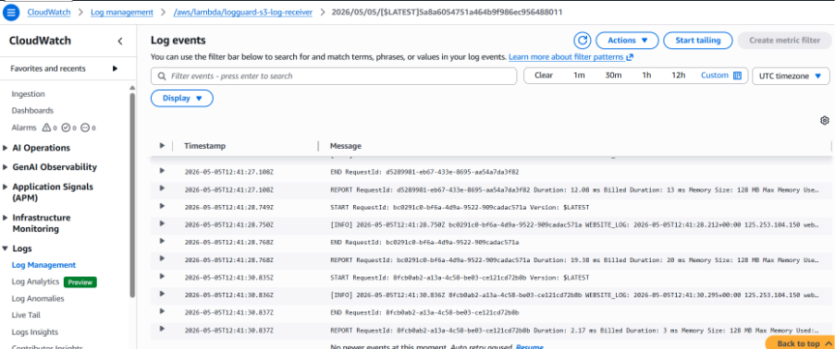
Figure 4: Website interaction logs appearing in CloudWatch
The website includes a built-in logging mechanism. Whenever a user interacts with important parts of the website, a log event is generated.
Examples of logged actions include page loading, navigation clicks, button clicks, card clicks, login attempts, and live monitor actions.
Each event is converted into a structured log message. The message contains useful details such as the event time, visitor information, website component, type of action, and a short explanation of what happened.
This makes the website activity look similar to real application logs. For example, a login failure or suspicious interaction can be represented as a log entry that can later be analysed by the anomaly detection model.
This stage demonstrates that the front-end website can behave like a live application log source.

Stage 3: API Gateway and Lambda Log Receiver
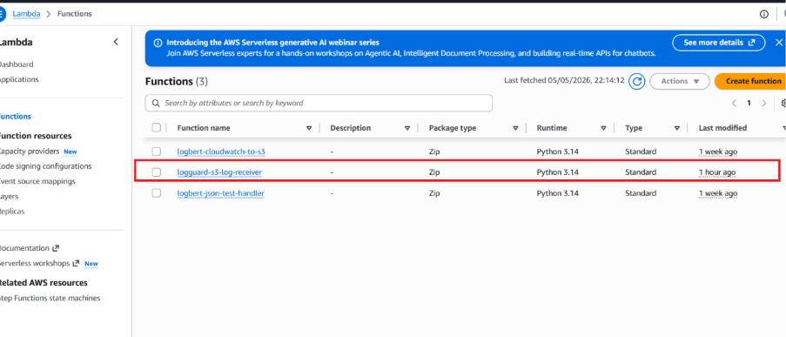
Figure 5: Lambda function list showing the website log receiver
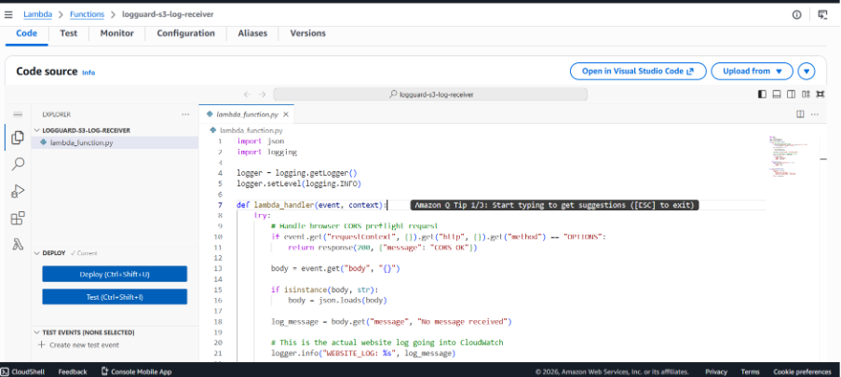
Figure 6: Lambda code screen for the website log receiver
The website does not send logs directly to CloudWatch. Instead, it sends the generated log messages through API Gateway.
API Gateway acts as the public receiving point for the website. When the website sends a log message, API Gateway triggers a Lambda function. This Lambda function receives the log, processes it, and writes it into CloudWatch.
This is a secure and practical design because the browser does not need direct AWS credentials. The website only sends a normal web request, while AWS handles the backend logging process.
The Lambda function also handles browser cross-origin requirements so that the S3-hosted website can successfully communicate with the AWS backend. The uploaded Lambda code shows that the function receives the message from the website, handles request processing, and writes the website log into CloudWatch.

Stage 4: Website Logs Stored in CloudWatc
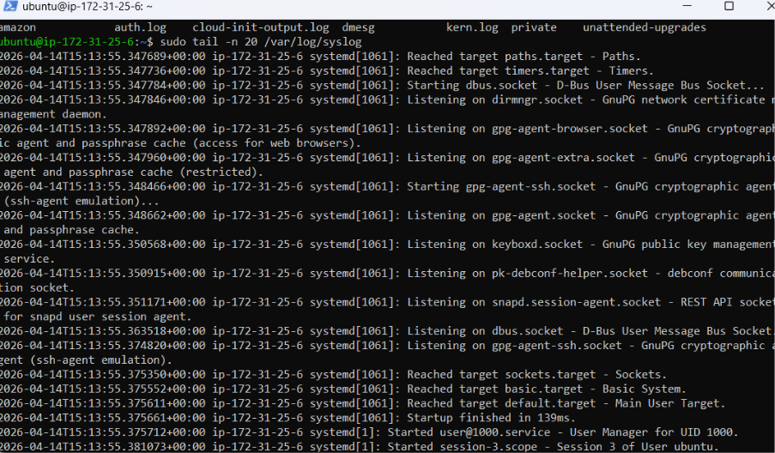
Figure 7: System logs stored and monitored, representing raw log collection before analysis
After the Lambda function receives the website log, the log is stored in Amazon CloudWatch Logs. CloudWatch becomes the central monitoring location for website activity.
The CloudWatch log stream contains both AWS-generated Lambda execution messages and the custom website logs. The custom website logs are the important ones because they contain the actual user activity from the website.
This stage confirms that the website, API Gateway, Lambda, and CloudWatch connection is working correctly. It proves that live user interactions from the S3-hosted website are successfully reaching CloudWatch.

8) Technical Accuracy and Depth
The technical depth of my contribution is evidenced by the sophistication of the JavaScript logging system, which goes well beyond a basic "send message to server" implementation. Specific technical features demonstrating depth include:
- Syslog Format Compliance: The log format produced by formatLogLine() matches the RFC 3164 / Unix syslog convention used in real server environments: TIMESTAMP HOSTNAME SERVICE[PID]: MESSAGE. This is not a simplified or approximate format — it is the exact format used in the HDFS and system log datasets the LogBERT model was trained on.
- Process ID Simulation: Each log entry includes an incrementing PID_COUNTER (starting at 1000), simulating a real Unix process ID sequence. This adds authenticity to the log entries and makes them indistinguishable in format from real system logs.
- Four-Output Event Pipeline: The logEvent() function simultaneously writes to four separate destinations — the monitor panel DOM element, the hero ticker DOM element, the toast notification system, and AWS CloudWatch via an async HTTP POST. Coordinating four outputs from a single event without race conditions or blocking required deliberate async design.
- Memory-Safe Monitor: The addToMonitor() function caps the live feed at 50 lines and removes the oldest entry when the limit is exceeded, preventing unbounded DOM growth during a long user session.

9) Critical Self-Assessment
Reviewing my contribution honestly, I can identify several areas where I performed well and several areas where I fell short of the standard I aimed for.

9.1 Strengths
The website I built is technically complete, functional, and above the complexity level originally scoped. The JavaScript logging pipeline — with real IP detection, syslog format, four simultaneous outputs, and XSS protection — demonstrates a level of engineering care that goes beyond the minimum required. The HTML Breakdown document I produced is comprehensive and shows a genuine understanding of every design decision in the code. The AWS architecture (S3 → API Gateway → Lambda → CloudWatch) is correctly implemented and was verified to work end-to-end.
I also managed the CSS architecture effectively. By using CSS custom properties (variables) for the entire colour palette, all visual changes can be made in one place. The responsive design, glassmorphism effects, and scroll animations add professional polish that strengthens the project's presentation quality.

9.2 Areas for Improvement
My most significant shortcoming was not anticipating the risk of AWS account suspension. A professional cloud deployment should always have a fallback plan — a secondary account, an exported infrastructure-as-code template (e.g. CloudFormation or Terraform), or at minimum a full set of screenshots and configuration exports captured before any disruption could occur. I did capture screenshots, but I did not prepare a rapid re-deployment plan, which would have allowed the live system to be restored more quickly.
A second area for improvement is the use of hardcoded credentials in the login section of the website (Lines 518–525 of index.html).
Finally, the current website sends logs through a Flask /log endpoint rather than directly to the API Gateway URL in some configurations. This adds a dependency on the Flask server running on EC2, which tightly couples the web frontend to the EC2 instance. The cleaner architecture — which the Lambda and API Gateway already support — is to have the website POST directly to the API Gateway endpoint, eliminating the Flask intermediary entirely. This is a planned improvement for the final submission.

10) Identification of Challenges and Problem-Solving Approaches
My work on this project encountered three major categories of challenge, each of which required a structured problem-solving approach.

Challenge 1: Learning HTML, CSS, and JavaScript from Scratch
HTML, CSS, and JavaScript were entirely new technologies for me at the start of this project. I had no prior experience with front-end web development. The challenge was not just to learn the syntax of three languages simultaneously, but to understand how they interact — how CSS properties cascade and are overridden, how JavaScript manipulates the DOM, and how asynchronous operations like fetch() work in a browser environment.
My approach to this challenge was structured and self-directed. I used MDN Web Docs as the primary reference for HTML and CSS specifications, W3Schools for quick practical examples, and the JavaScript.info tutorial for understanding async/await and Promises. I also studied real-world HTML structure by inspecting the source of existing cybersecurity dashboards to understand how professional dark-mode interfaces are constructed.
The result of this learning effort is visible in the sophistication of the final code: CSS custom properties (variables), glassmorphism effects, IntersectionObserver-based scroll animations, async fetch with error handling, and DOM manipulation using createElement/appendChild rather than innerHTML injection — all of these are intermediate- to advanced-level web development techniques that I learned and applied during this project.

Challenge 2: AWS Services — API Gateway, Lambda, CloudWatch, and S3
AWS was also largely new territory for me. The challenge with AWS is not just learning individual services but understanding how they connect: how an API Gateway trigger invokes a Lambda function, how Lambda writes to CloudWatch Logs, how S3 bucket policies control public access, and how IAM permissions govern what each service is allowed to do to the others.
My problem-solving approach was to work through each service in isolation before attempting to connect them. I first set up the S3 bucket and confirmed the website was accessible via the public endpoint. I then created the Lambda function independently and tested it using the built-in Lambda test event interface to confirm it was writing to CloudWatch. Only after each component was verified individually did I add the API Gateway trigger and test the end-to-end flow from the website.
This incremental approach — build one component, verify it, then connect to the next — meant that when issues arose (such as CORS errors, which blocked the first round of browser-to-Lambda requests), I could isolate the problem to the specific connection point rather than debugging the entire pipeline at once. The CORS issue was resolved by adding an OPTIONS pre-flight handler to the Lambda function, which returns the required Access-Control-Allow-* headers before the browser will allow the POST request to proceed.

Challenge 3: AWS Account Suspension
The most disruptive challenge I encountered was the suspension of the AWS account used for this project. This occurred after the website, API Gateway, Lambda, and CloudWatch pipeline had all been deployed and verified as working. The suspension meant that the live demonstration of real-time website logs flowing into CloudWatch cannot currently be shown through a live environment — only through the screenshots captured before the suspension.

11) Evidence of learning and improvement
For HTML CSS and javascript I use these below site for reaching my understand in a good level:
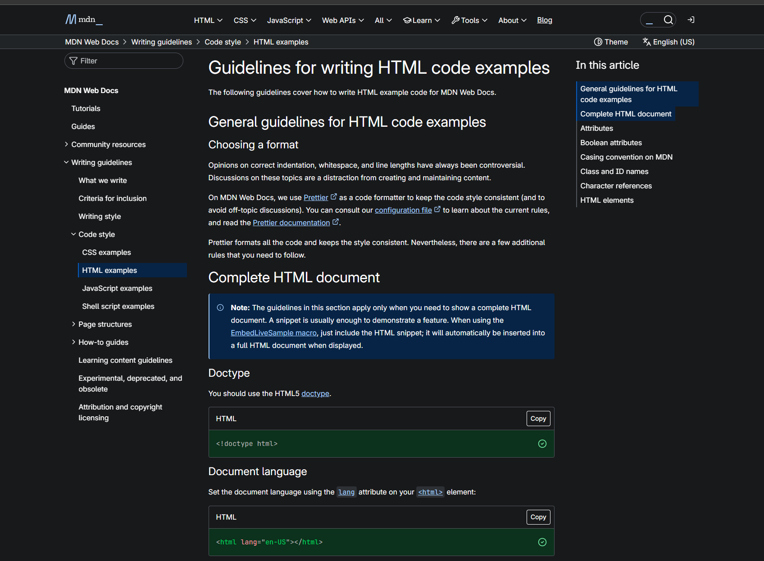
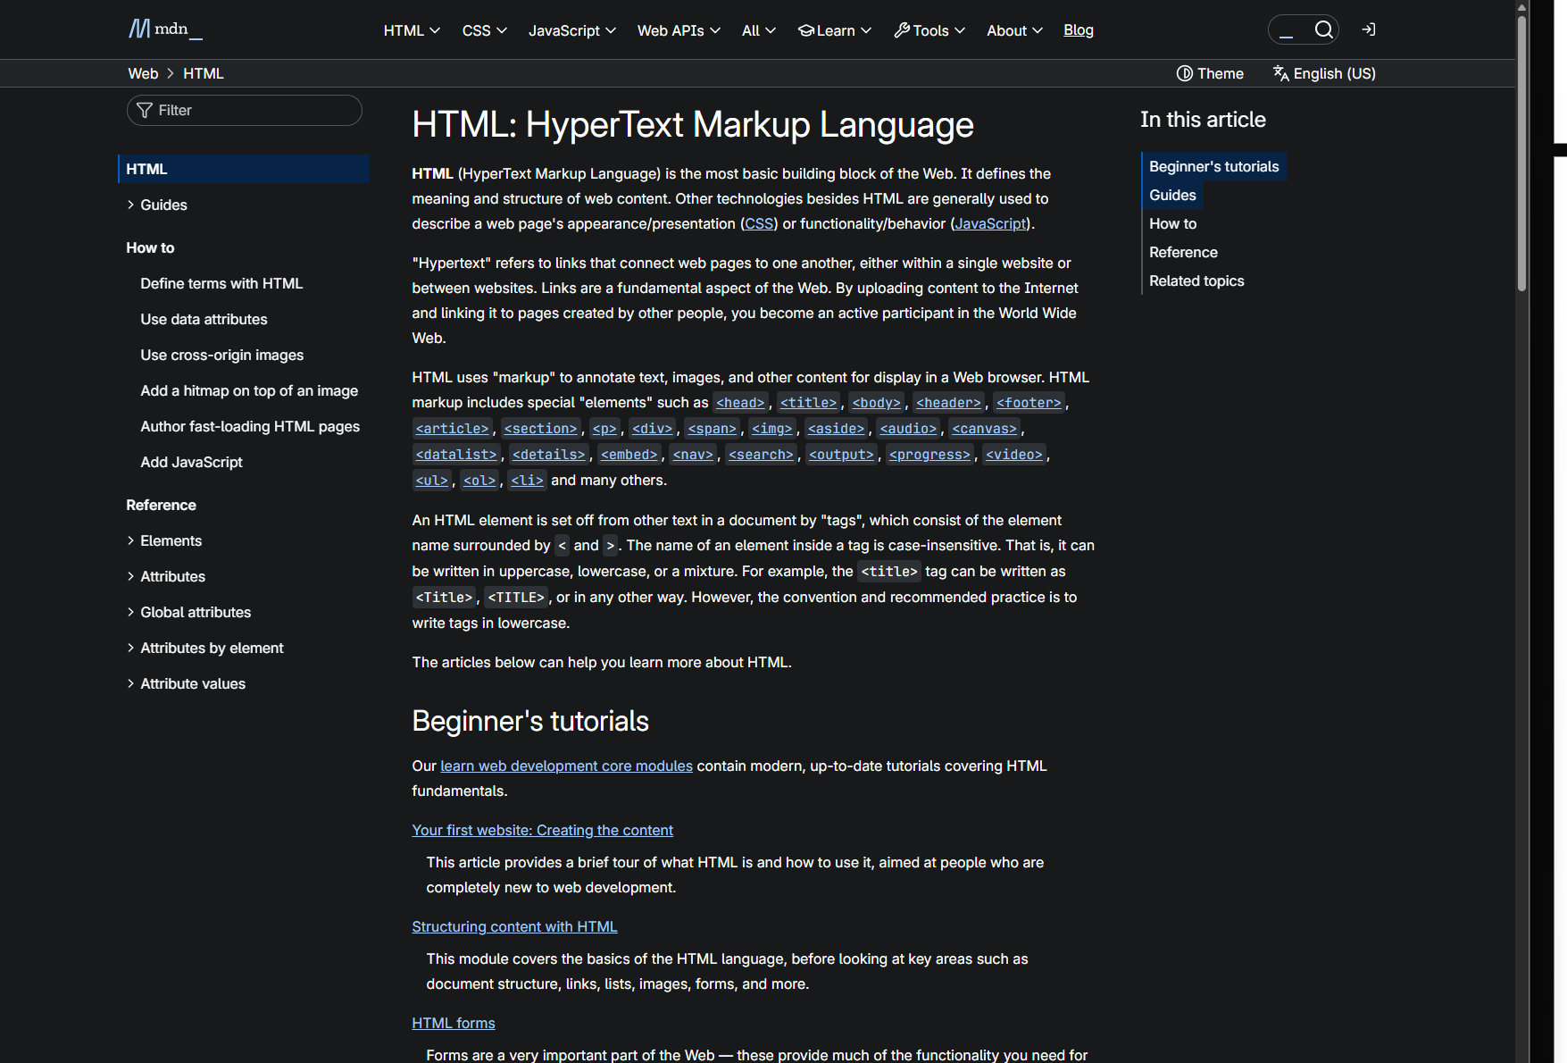
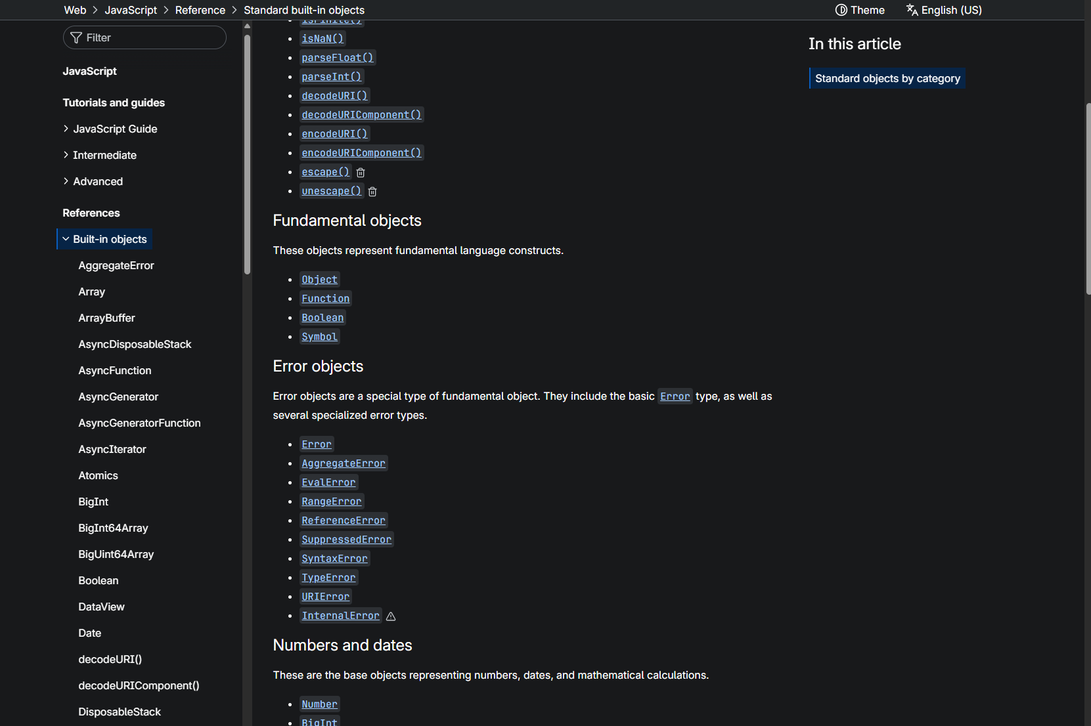
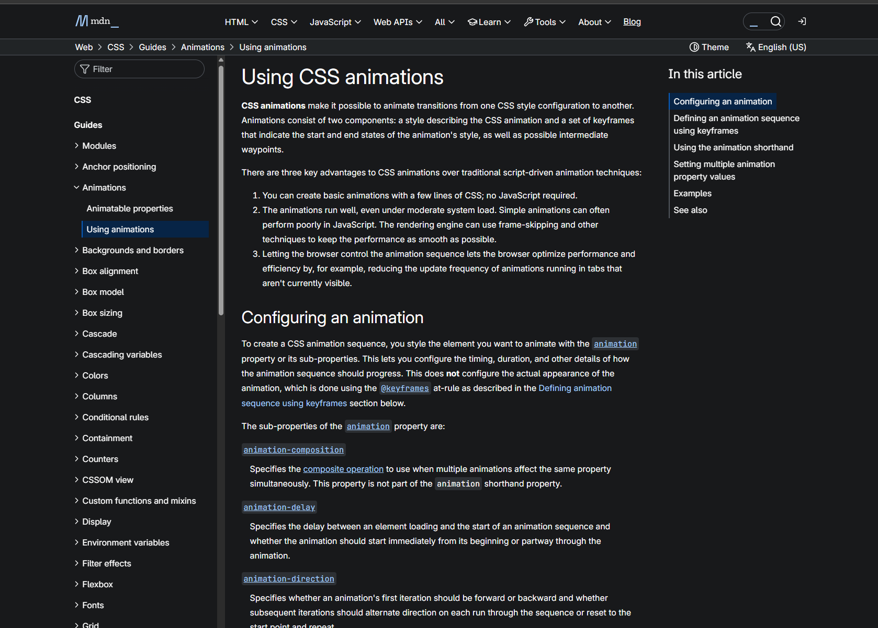
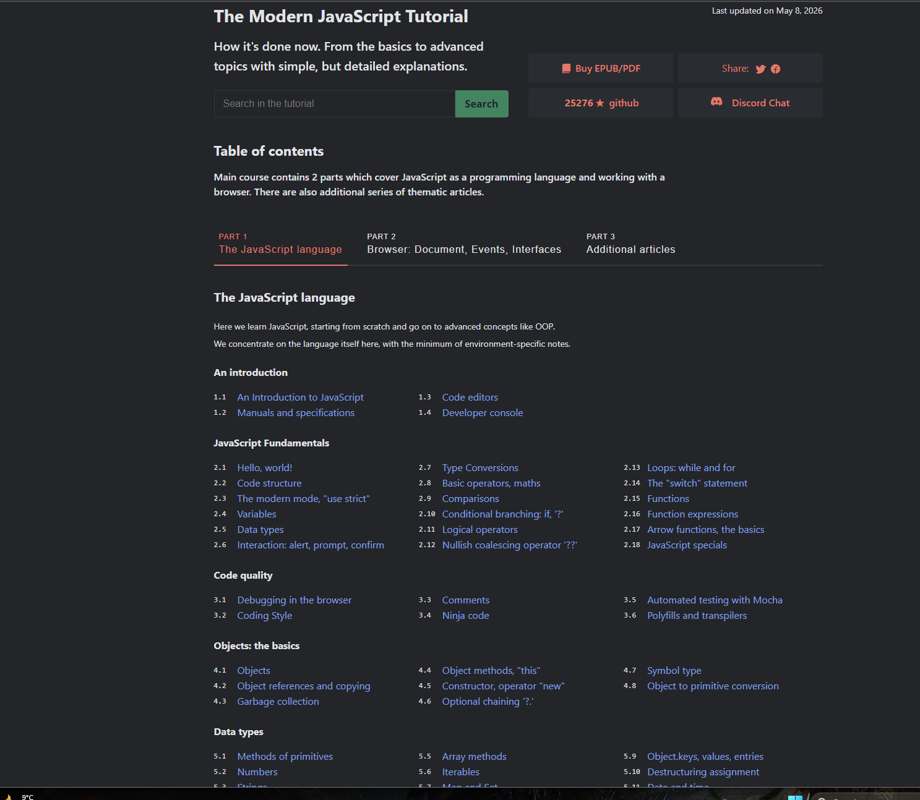
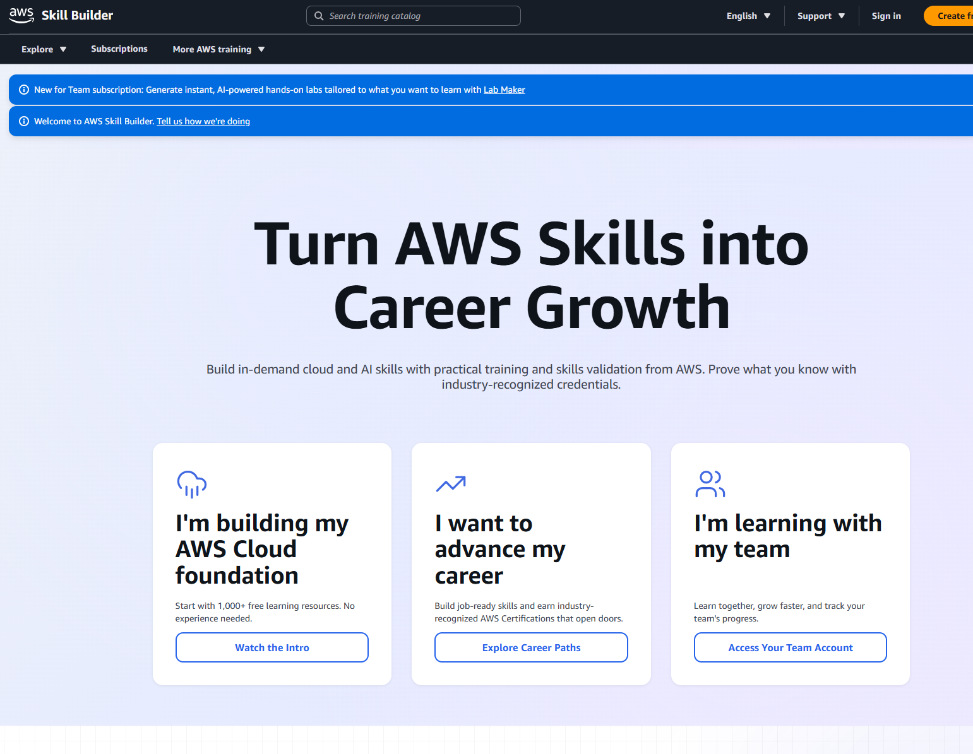
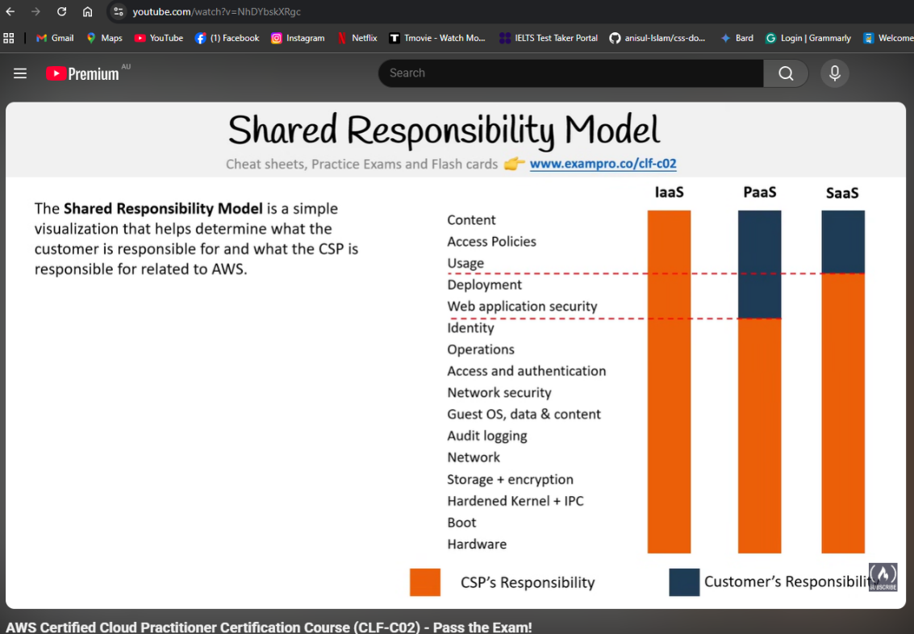
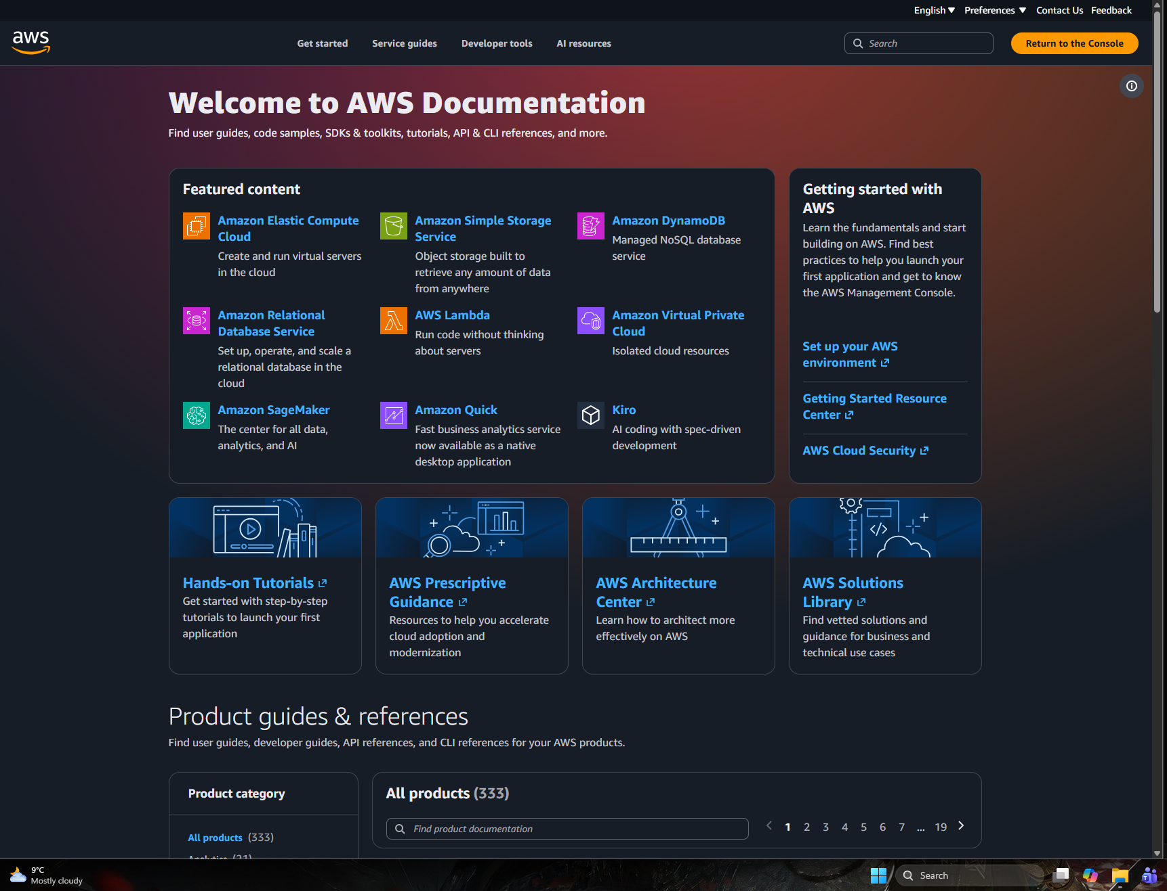

12) Plan for the rest of the project:

As I mentioned that our previous aws account was suspended and cloudwatch real log data store process was gone but we have done most the job like build the website again and published in the aws as well as other things are working are now like real log generate but the real log is not store in the cloudwatch.
so our next plan is to do the cloudwatch part so we can store the real log data which is generated by the user in the website.

